Grant Harvey - Project 2 Documentations

A* Implementation
In this project, I implemented an A* Search function to solve the 8-puzzle problem.
The function h(n) counts the number of misplaced tiles compared to the goal state. For example, if the goal is [1,2,3,4] and the state is [1,3,2,4], then h(n)=2. This should be admissible because it never overestimates the true cost to reach the goal.
For every state we see, we store a tuple containing f, g, state, and the path taken to reach that state. At the beginning of a while loop we use heappop to grab the state with the lowest f value, we store it as visited in a set, and then we add any new states that we now see as neighbors from this state. This continues until our state matches the goal state.
When the goal state is reached, the algorithm outputs the path and prints it for us in the view in the console, then it returns it. The path is built during the while loop.
Achievements:
- Successfully implemented A*
- Successfully calculated f(n) = g(n) + h(n)
- Prevented repeated states from being explored by using a visited set.
- Correctly reconstructed a solution path once the goal state was found.
Limitations:
- h(n) may have a more accurate algorithm to calculate it, but I am not sure what it is.
- Performance may degrade for deeper solutions due to repeated calls.
Snapshots Included:
- Initial scrambled board configuration.
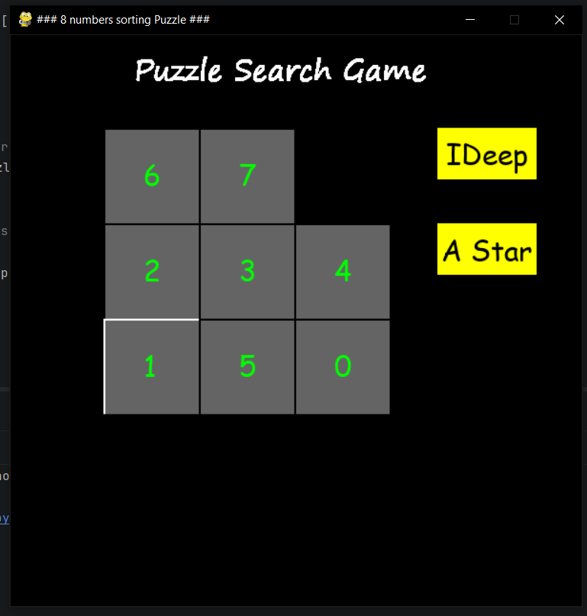

- Final completed board configuration.
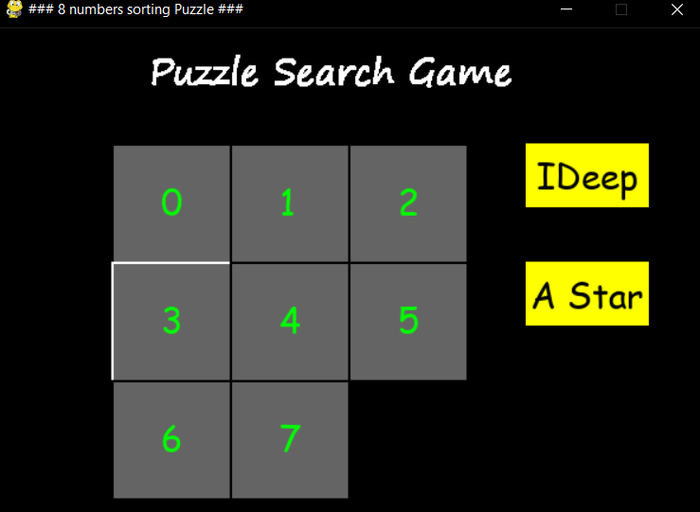

- Console Messages
